**[F29DC 2024 Lab 1 - Connectivity, VPCs, Subnets, VLANs](https://canvas.hw.ac.uk/courses/28951/files/3694381?wrap=1" \o "F29DC 2024 Lab 1 - Connectivity, VPCs, Subnets, VLANs.pdf" \t "_blank)  
- Shyam Sundar Velmurugan  
- H00418621**  
  
{ Part 1 }   
Connectivity and Virtual PCs ( VPCs )  
  
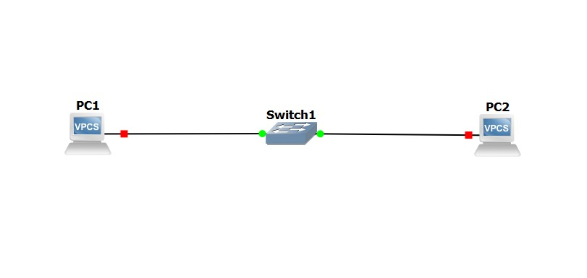

Image .1 : Setting up the connection between Switch1, PC1 and PC2.

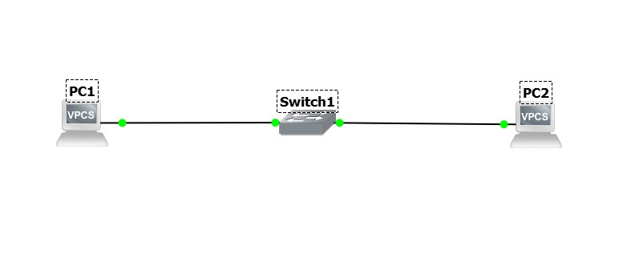

Image 1.2: Starting up all the connections.

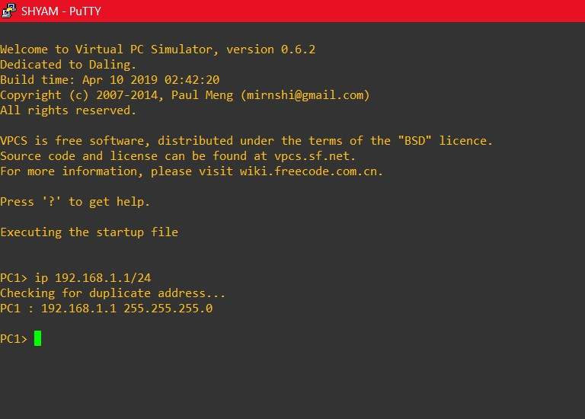

Image 1.3: Providing the IP address for the PC1.

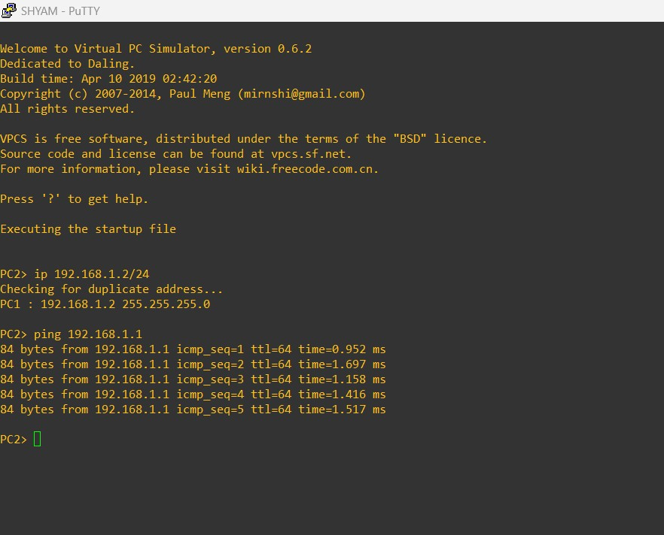

Image 1.4: Providing IP address for PC2 and testing the connectivity by pinging 192.168.1.1 from PC2.